Exercise 01

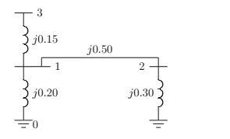
Using the method of building algorithm ﬁnd the bus impedance matrix for the network shown in Figure
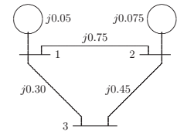
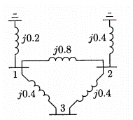

One-line diagram_1 One-line diagram_2 One-line diagram_3

Exercise 02

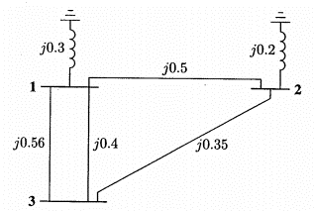
Line from bus 1 to 3 with impedance Z₁₃ = j 0.56 is removed, Using the method of building algorithm to determine the new bus impedance matrix.

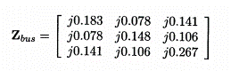

Exercise 03

There is a line outage and the line from bus 1 to 2 with impedance Z₁₂ = j 0.8 is removed. Using the method of building algorithm determine the new bus impedance matrix.

