- Convert network impedances to admittances and obtain the bus admittance matrix by inspection.

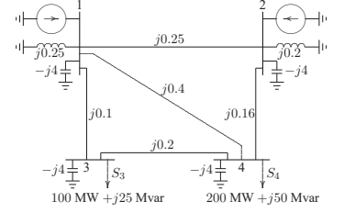

- Determine the bus admittance matrix by inspection

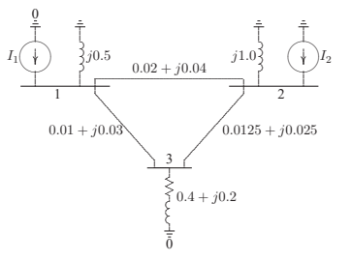
- Determine the bus admittance matrix by inspection

