LESSON FOUR : The US Geography
- Location and Borders
With an area of 3,615,122 square miles (9,363,123 square kilometers), the United States is exceeded in size only by Russia, Canada, and China. Of the fifty states, forty-eight lie between the Atlantic and Pacific Oceans, and between Canada and Mexico. Alaska lies in the northwest corner of the continent; it is bordered by Canada to the east, the Gulf of Alaska and the Pacific Ocean to the south, the Arctic Ocean from to north, and shares a maritime border with Russia to the west. Hawaii, on the other hand, is situated in the southwest of the continent. It has no borders with any of the states of the USA. It is an island in the north of the Pacific Ocean. It is the only state that does not lie in North America.
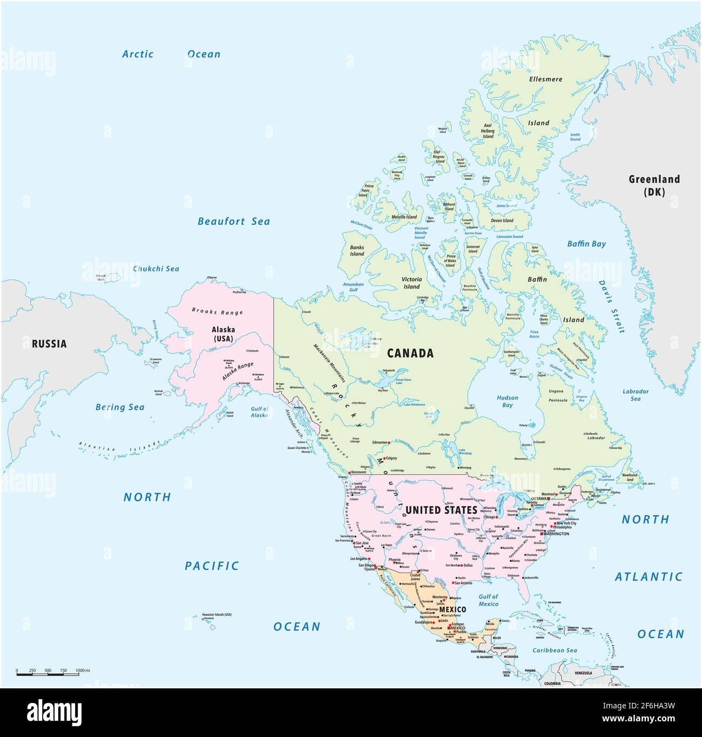
A detailed map of the USA including Alaska and Hawaii
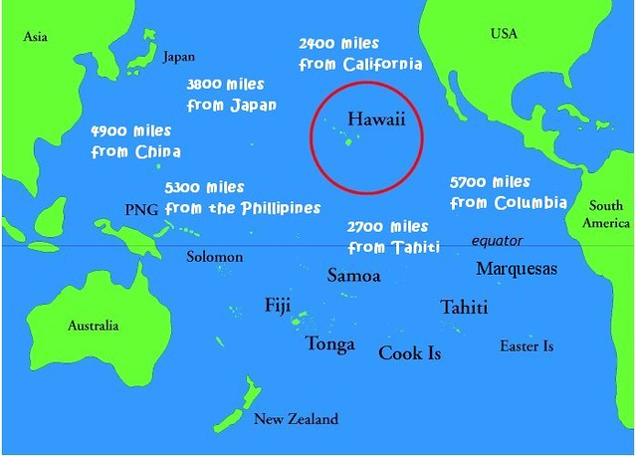
Hawaii to North America and other locations
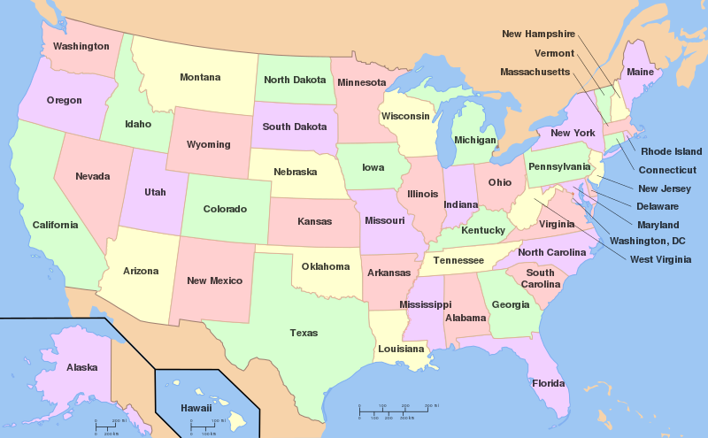
The states of the USA
- The Physical Geography of the USA and its Natural Resources
The U.S. geography is characterized by variety; from arctic to tropical, rainforest to desert, from vast plains to rugged mountains.
Five main geographic regions can be identified in the USA:
- The Atlantic Plain: It is the first land formed in the USA near the Atlantic Ocean and the Gulf of Mexico. As it extends to the coast of the Gulf of Mexico, it can be described as the Atlantic Gulf Plain. The plain is a coastal low land stretching from New England¹ to the middle of Texas. It starts as a narrow strip in the North and widens gradually to include larger parts of the southern states.
Although its soil is mostly poor, it includes a fertile citrus-growing and the Cotton Belt in the south, which have both been intensively developed for commercial farming. The Plain's most important natural wealth is found along and in the Gulf, where much of the nation’s crude-oil and natural-gas reserves are located. Water pollution from industrial development in the North and commercial fertilizers and oil-drilling in the South have posed the most serious threats to the Plain's environment. Drilling for petroleum off the East Coast has become a more serious alternative despite environmentalists’ protests.
- The Piedmont: Inland from the Atlantic Plain, the land rises to the Piedmont, a gently rolling fertile plateau. Along the eastern edge of the Piedmont is the fall line, where rivers running down to the Atlantic form waterfalls. When water power was used for grain and textile mills, America’s first industrial cities grew up along the northern fall line near the coast.
- The Appalachians: The Piedmont rises to the Appalachians, much-eroded mountains from Canada to Alabama that separate the eastern seaboard from the interior. These mountains, the Appalachian Plateau, and the rugged ridge and valley country to their west delayed European invasion and settlement.
Although the Appalachians and the upland sub-regions contain minerals, only iron, building stone and coal are found in large quantities. The coal deposits in Pennsylvania and West Virginia, in the area called Appalachia, are among the world’s largest and once provided fuel for developing industry in the north-east and the Great Lakes region as well as for heating homes across the nation. Today, Appalachia is among the nation's most depressed areas because ‘cleaner’ gas, oil and atomic energy have partially replaced coal. Producing and using these newer energy sources, however, has also been identified as the main cause of air pollution and acid rain.
- The Central Lowland: It lies west of the Appalachian highlands. It is a vast area stretching from New York state to central Texas and north to Canada, which resembles a huge, irregular bowl rimmed by the Great Lakes and highlands. The iron ore in one of these, the Mesabi Range at the western edge of the Lakes, transported inexpensively over the Great Lakes to the coal of Appalachia, made the development of America's industrial core possible.
The Central Lowland is varied in terms of nature, rainfall and temperature; it is not entirely flat, rainfall decreases towards the west, and also from north to south, the long winters of the Upper Midwest change to the snow-less winters of the gulf states.
The natural resources of the Central Lowland, which is often called the nation's breadbasket, are its soil and fossil fuels. The fields of oil and gas in Texas, Oklahoma and Kansas were the nation's most important domestic supply until reserves in Alaska were tapped. Across the lowland the increase in large-scale agribusinesses in recent years has produced intense efforts to deal with unwanted side effects, including polluted water supplies from plant fertilizers and insecticides and the leakage of concentrated animal feed and sewage from industrial pig, chicken and freshwater fish farming.
- The Great Plains: is a band of semi-arid territory almost 500 miles (800 kilometers) wide between Canada and Mexico. The plains rise so gradually towards the west that large parts of the region appear to be utterly flat. Most of the plains, however, are broadly rolling, and parts of the northern plains are cut up into spectacular gorge and ridge country called ‘badlands’. The buffalo grass of the plains makes them excellent for ranching, but some areas, watered by automated artesian wells or irrigation, are now high- yield farm country. The Plains’ mineral wealth, mainly low-grade brown coal, is extracted through environmentally damaging strip-mining, which grows in economic viability as the world price of oil rises.
- The Cordillera Mountain Chains (The Rockies and the Pacific ranges): The region is to the western edge of the Great Plains and represents a third of the continental United States. Between the chains are basins and plateaus. Near the Southern Rockies’ western slopes is the Colorado Plateau, a maze of canyons and mesas, the most famous of which is the Grand Canyon. Surrounding the Plateau is the desert Southwest. Valleys and plains rather than mountains occupy much of the Middle Rockies. In the northern Rockies are vast wilderness areas and the Columbia Basin, which is etched by the remarkable canyons of the Snake and Columbia rivers.
The western arm of the Cordillera consists of two lines of mountains with a series of valleys between them. In from the coast are the highest peaks, including active volcanoes.
The inland valleys in the more southerly of the western arm of the Cordillera are excellent for growing food crops, fruits and vegetables, in favor of the rich soils and the relatively easy irrigation The mountains between the valleys and the coast include major earthquake zones, such as the San Andreas Fault.
The American Cordillera are world-famous for veins of precious metals, such as the gold of the Sierra and Yukon and the Comstock silver lode of Nevada. More recently, industrial metals such as copper and lead have been mined. Large occurrences of oil and gas are found in California and Wyoming, and the Colorado Plateau contains uranium, oil shale and soft coal.
The natural riches of Hawaii are vegetable rather than minerals.
- Famous Physical Features
- Great Banks contain many kinds of fish and attracted fishermen from Europe even before European settlers established their first colonies in the New World
- The Florida Current makes the east coast to have a warmer climate
Current. Fine harbors and estuaries made the sites of New York City, Philadelphia and Baltimore excellent locations for trade.
- The Mississippi, with its major tributaries: One of the world's great inland water networks
- The Great Lakes are the biggest group of freshwater lakes in the world and carry more shipping than any other inland lake group.
- The Columbia, the Colorado and the San Joaquin-Sacramento Rivers (in the Cordillera) do not support shipping but they have brought prosperity by providing hydroelectric power and irrigation.

