LESSON THREE : The Country of the United States
The United States of America is union of 50 states in North America. It composed of those 50 states, a federal district_ Washington, DC,_ five major self-governing territories, and various possessions.
- The Establishment, Expansion and development of the country
Paleo-Indians migrated from Siberia to the North American mainland at least 15,000 years ago. European colonization began in the 16 century. The US emerged from the thirteen British colonies established along the East Coast. Numerous disputes between Great Britain and the colonies following the French and Indian War led to the American Revolution in 1775, and the subsequent Declaration of Independence in 1776. The war ended in 1783 with the US becoming the first country to gain independence from an European power. In 1987 the founding fathers wrote the US constitution, that is the country supreme legal document.
- Government and Politics
- Background of the US Government Formation
Americans have been very careful to their value of individual freedom. For them, every single aspect of American life, rules, laws, the government…. should serve individualism. They believe that government is the natural enemy that endangers their freedom. This suspicion of strong government goes back to the men who led the American Revolution; those experienced the powerful British government that restricted the freedom of the colonies in the US and imposed heavy taxes on them, as being the world’s superpower at that period.
When they wrote the Constitution, these men thought of keeping the government from doing evil than with enabling it to do good. They organized a government that can be described as being weak because of its division, the system of elections, and the checks and balances system.

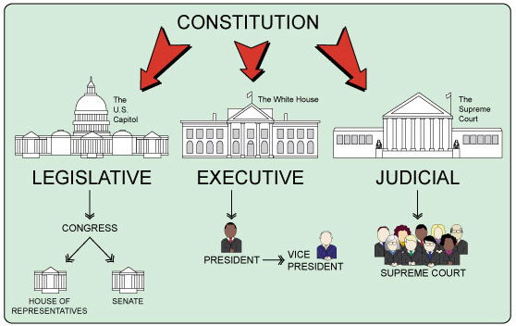
- The Structure of the US Government

- The Legislative Branch: The bicameral Congress, made up of the Senate and the House of Representatives. Congress makes laws, approves treaties and appointing government officers (Senate), approves military actions (House), has the power of the purse and the power of impeachment. The Senate includes 100 senators divided among the states equally (each state has two senators) regardless population while Representatives are divided among the states by means of population. The House consists of 435 representatives who are elected every two years whereas senators are elected for six-year terms with one third of them run for re-election each time House elections are held.
- Executive Branch: The President id the commander-in-chief of the military. He carries out the laws, can veto legislative before the become law (subject to congressional override), appoints the members of the Cabinet and other offices (subject to senate approval), and takes military actions (with the House approval).
- Judicial Branch: The Supreme Court and lower federal courts whose judges are appointed by the President with Senate approval, interpret laws and overturn those they find unconstitutional. The Supreme Court, led by the Chief Justice of the US, has nine members who serve for life.
- The Checks and Balances System
If any one of the three branches starts to abuse its power, the other two may join together to stop it, through a system of checks and balances. The Constitution is most careful in balancing the powers of the legislative and executive branches of the government because these two (Congress and the president) are the most powerful of the three branches. In almost every important area of governmental activity, such as the power to make laws, to declare war, or to conclude treaties with foreign countries, the Constitution gives each of these two branches enough power to prevent the other from acting on its own.
- Elections in the US
The president and both houses of Congress have almost complete political independence from each other because they are all chosen in separate elections. For example, the election of the Congress does not determine who will be elected president, and the presidential election does not determine who will be elected to either house of Congress. In the US there are two leading political parties, the Democrats, who are. traditionally liberal or progressive, and the Republicans, who are more conservative.
Because elections of the president and members of the two houses of Congress are separate from each other, it is quite possible in the American system to have the leader of one political party win the presidency while the other major political party wins a majority of the seats in Congress.
Presidential elections: Every four years, presidential elections take place in the United States. today In presidential elections, people are actually voting for representatives called electors, and it is these electors who officially choose the president. With the electoral college system, the winner of the plurality (the highest number) of each state's popular votes gets all of that state's electoral votes, in most cases. (There are several exceptions.) The number of each state's electoral votes is equal to the total number of their representatives in the House and the Senate. In total, the Electoral College consists of 538 electors.

Electing a President is a long process, which consists of two major election processes by means of the ‘Electoral College’. First, the primary elections take place at the level of, individuals vote for representatives_ electors_ belonging to the two parties. The winner of the highest number of popular votes gets all of that state’s electoral votes. Then, “the process of the actual presidential election begins.

