Ministry of Higher Education and Scientific Research

Hamma Lakhdar University of El-Oued
Faculty Of Arts and Languages
Department Of English Language
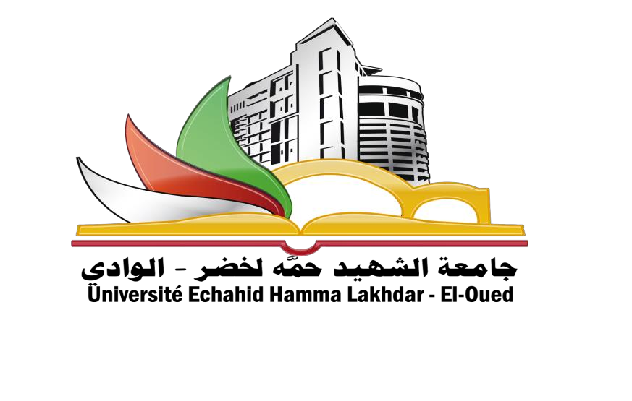
Didactics
Level : Master Two

Academic Year: 2021/2022

Module : Didactics / 3 h (Cours + TD) /
Credits /4 / Coef 2

Third Semester
1. A Brief history of language teaching approaches
2. Competency-based approach
3. Eclectic approach
4. Course and syllabus design
5. Curriculum development
6. Lesson planning
7. Teaching the language system (grammar, vocabulary, and pronunciation)
8. Teaching language skills (reading, listening, speaking, and writing)
9. Culture in EFL teaching
10. ICT integration in EFL classes

